 |  |  | PES UNIVERSITY, BANGALORE-85  (Established under Karnataka Act 16 of 2013)  END SEMESTER ASSESSMENT, B. Tech. IV SEM  Jan-May 2020  (Model Question Paper)  Linear Algebra and its applications | UE18MA251
Sub Code: UE18MA251
Time: 3 Hrs Answer All Questions Max Marks: 100
1. | a) | Explain why 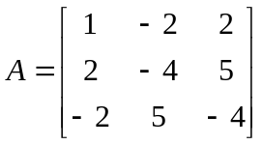 is not factorizable into LDU? How can A be modified so that the new matrix can be factored? Also obtain the factors L , D and U for the new matrix . What is the relation between L and U thus obtained? Explain |  |  | 7
1. | b) |  |  |  | 7
  Determine the values of a and b for which the system of equations x + y + a z = 2b , x + 3y + ( 2 + 2a ) z = 7b ,
  3x + y + ( 3 + 3a ) z = 11b will have (i) unique nontrivial solution (ii) trivial solution ( iii ) no solution (iv) infinity of solutions.
1. | c) | Using Gauss-Jordan method to find 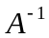 where 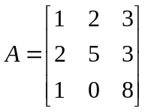 |  |  | 6
2. | a) | Discuss whether the given system of equations  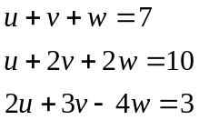  is ‘Singular ‘ or ‘Non singular’(where A refers to coefficient matrix)  based on :  1) Rank of the matrix 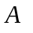and 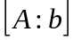.  2) Invertibility of the matrix A.  3) Column Space of matix A.  4) Null space of the matrix A.  5) left null space of the matrix A |  |  | 7
2. | b) | Find a basis for each of these subspaces :  1) All Diagonal matrices of order 3 by 3 .  2) All symmetric matrices of order 2 by 2.  3) All vectors in 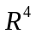whoose components add to zero.  4) All vectors in whoose components are equal.  5) All polynomials of degree 3.  6) All skew symmetric matrices of order 2 by 2 |  |  | 7
2. | c) | Obtain a basis for 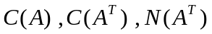 given that 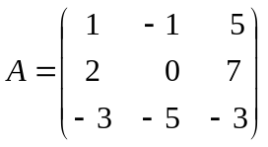 . Determine whether the vector 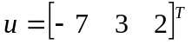 is in the nullspace of  . |  |  | 6
3. | a) | Find a basis for the plane 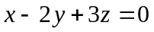 in 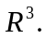Then find a basis for the intersection of that plane with the xy plane. Then find a basis for all the vectors perpendicular to the plane 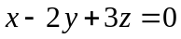. |  |  | 6
3. | b) | Fit a plane 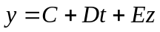 to the four points by the method of least squares, given 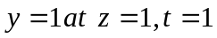 ; 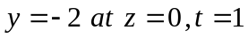 ; 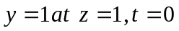; and 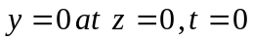. |  |  | 8
3. | c) | From the cubics P3 to the fourth degree polynomials P4, what matrix represents multiplication by 3t – 5 ? |  |  | 6
4. | a) | Find an orthonormal set q1, q2, q3 for which q1 and q2 span the column space of  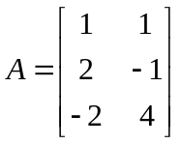Which fundamental subspace contains q3 ? What is the least squares solution of Ax = b if b = ( 1 , 2, 7 ) ? |  |  | 8
4. | b) | Determine the numerically largest eigen value and the corresponding eigen vector corresponding of the matrix 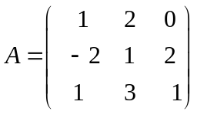 using the initial approximation as 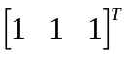 .upto seven iterations . |  |  | 7
4. | c) | Use the Gram – Schmidt process to find a set of orthonormal vectors from the independent vectors a1 = ( 1, 1, 1 ) , a2 = ( 0, 1, 1 ) and a3 = ( 0, 0, 1 ). Also find the  A = QR factorization where A = [ a1 a2 a3 ]. |  |  | 5
5. | a) | Obtain the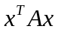for the matrix 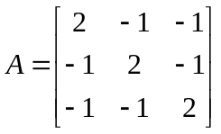and check if the matrix is positive definite or not by 1) eigen value method 2) pivots method |  |  | 8
5. | b) | Obtain Singular Value decomposition of the matrix 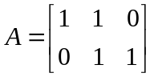 |  |  | 12

--------------------------------------------

